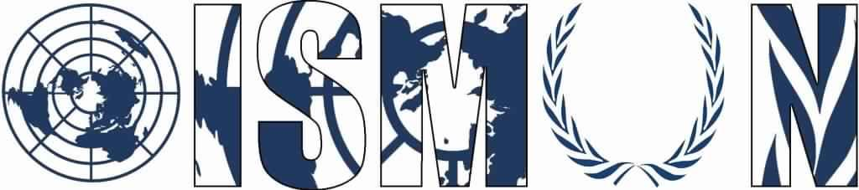

OASIS INTERNATIONAL SCHOOL MODEL UNITED NATIONS

United Nations Office on Drugs and Crime

President: Farida Abu Arab

Vice-president: Aly Imam

Guiding Package

Topic: Abolishing corruption in North Africa and the Middle East
11th Annual OISMUN Conference

Table of Contents
- Abstract1
- Introduction2
- Definition of key terms 3
- Background information5
- Major countries and organizations involved7
- UN involvement 8
- Possible solutions 9
- Guiding questions9
- Useful links 10
- Bibliography11

- ABSTRACT
Grand corruption is one the great unresolved challenges of our day. It poses serious danger and with its serious and global effects. This issue has to be considered as an international crime, as corruption not only affects the country it’s in but also affects its surroundings. Corruption is considered as a major obstacle in achieving sustainable development, as well as it undermines the financial practice and clean business, both locally and internationally which is a cause of the increase of poverty and inequality worldwide. Corruption also results in violation of human rights, which is recognized by the UN High Commissioner for Human Rights (UNHCR).
In the late 2014, it was found that corruption was considered as the most important cause of the Uprisings in the Middle East and North Africa (MENA) region, especially in Iraq, Libya, Morocco and Tunisia, while in Egypt and Jordan, it came second after economic problems.
And while looking back at the international community, North Africa and the Middle East is the area with countries with the highest percentage of corruption, as well as worst rankings in the international corruption index.

- INTRODUCTION
Public dissatisfaction with corrupt leaders and regimes has been the cause of change in the Middle East and North Africa, especially with the Arab Spring protests, which began in 2010 and flew across the region in the years following. Although many years have passed, however, public dissatisfaction still widely exists in 61% of the population because of the fact that corruption has highly increased in the past years and that many of the government officials and Members of Parliament are highly corrupt.
Transparency International’s annual Corruption Perception Index (CPI) constantly ranks MENA countries below the world’s average percentage (with some variations with other countries) with Jordan and Tunisia having the best rankings among the region and Yemen and Syria remaining at the bottom of the ranking.
Domestic authorities are often unable or unwilling to bring the corrupt people or organizations to justice. In these cases, the international community is obligated to act, collectively and through action by individual states. Corruption is a crime that violates human rights and deserves punishment accordingly, and when it comes to effectively fighting corruption, good evidence of what works is not the only thing needed but it also requires time, effort and strong political will.

- DEFINITION OF KEY TERMS

- Corruption: A public official or another person deprives a particular social group or substantial part of the population of a State of a fundamental right; or causes the State or any of its people a loss greater than 100 times the annual minimum subsistence income of its people; as a result of bribery, embezzlement or other corruption offence.

- Bribery: The act of promising, giving, receiving, or agreeing to receive money or some other item of value with the corrupt aim of influencing a public official in the discharge of his official duties.

- Impunity: Exception from punishment or freedom from the injurious consequences of an action.

- Minimum subsistence income: A socially recognized minimum level of income of a person; any person whose income is below this level is considered to be in material need.

- Government official: Official, employee or any agency, ministry or department of a Government.
- Fundamental rights: Some universally recognized rights that are seen as essential

- Public sector: Organizations or services that are owned and operated by the government and exist to provide services for its citizens.

- Private sector: The private sector is the part of the economy that is run by individuals and companies and is not controlled by the government.

- BACKGROUND INFORMATION

Corruption creates much anger in the Middle East and North Africa, it was government corruption that sparked the greatest anger among the population.
Fig.1
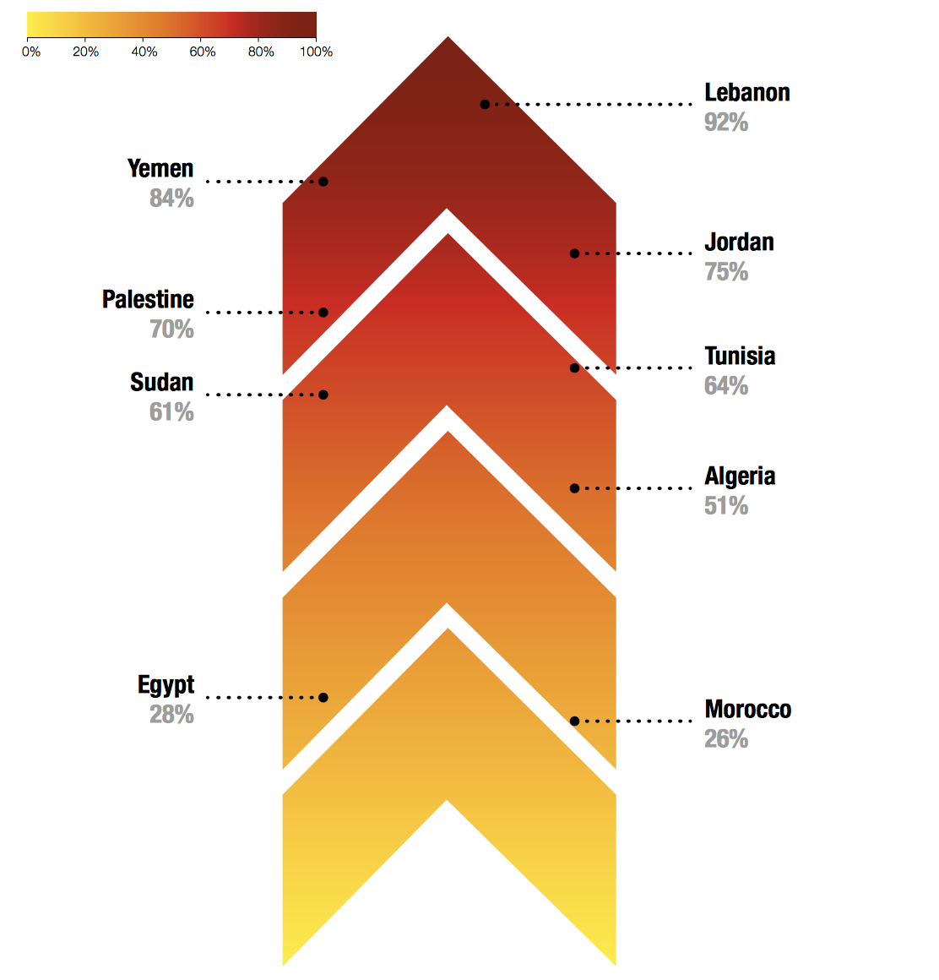
This diagram shows the change in the corruption percentage in each country and whether it has increased or not.
Corruption has risen in North Africa and the Middle East and after the evaluation and report of Transparency international on Middle Eastern and North African countries it was shown that Yemen and Lebanon are countries with most corruption with a percentage of 84% and 92% respectively.
In North Africa and the Middle East, almost 1 in 3 people have to pay bribes to have access to the basic needs such as water, education or medicine. Which is equivalent to around 50 million people. Which means that people living under the poverty line don’t have access to the basic needs while they fully have the right to do so without having to pay a bribe to government officials.
Most people believe that corruption is mainly present in the public sector since it’s controlled by the states government, and while corruption is present in different institutions and groups in society, but this sector is mostly the cause of corruption, and the percentage differs depending on the country, as we see in the following graph;

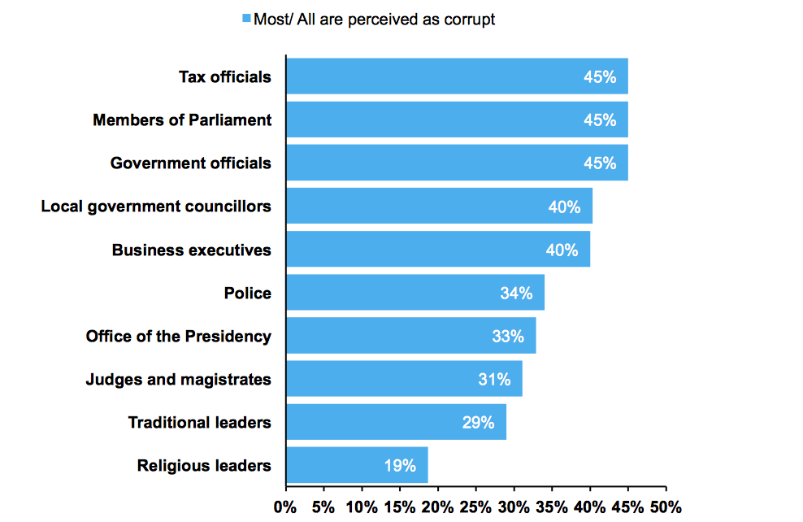

As corruption originates from the government of a country itself, its less likely for this government to admit the existence of corruption in the country. And as found in North Africa and the Middle East, governments are not doing their best in battling corruption, as the regional average percentage of effectively fighting corruption is 26%. Therefore, its essentials that all countries must collaborate in order to eliminate the risk in the region, and get one step closer to achieving sustainable development.

- MAJOR COUNTRIES AND ORGANIZATIONS INVOLVED
- Yemen
Is considered most corrupt country in the region with a score of 16/100 (according to transparency international), as well as it’s the poorest country in the Middle East. Its corruption increases due to internal and political conflicts in the country, and the constant lack of security.

- Iraq, Libya, Sudan, Syria
Countries from the Middle East and North Africa that are one of the bottom ten countries with worst and highest percentage of corruption, due to economic, governmental and political non-stability, which leads to lack of security in the country.

- Tunisia
The only Middle Eastern and North African country that has an average percentage of corruption, puts efforts into battling corruption and one of the few countries that has improved on the index.

- Transparency international
A non-governmental organization with its main goal to fight corruption worldwide. They work with governments, businesses and citizens in order evaluate the corruption’s presence worldwide, create surveys and overviews annually and provide solutions to corruption internationally.

- UN INVOLVMENT

The UN General Assembly put into place the only legally binding universal anti-corruption instrument. The United Nations Convention against Corruption (UNCAC) covers five main areas: preventive measures, criminalization and law enforcement, international cooperation, asset recovery, and technical assistance and information exchange, and it covers many different forms of corruption, such as bribery, trading in influence, abuse of functions, and various acts of corruption in the private sector.
Within the UNODC’s overall responsibilities and the implementation of The United Nations Convention against Corruption, its established and protected by the Corruption and Economic Crime Branch (CEB) in the division for Treaty Affairs (DTA) that supports states in the implementation of the convention.
The UNODC also holds the Conference of the States Parties (COSP) as the main policy making body of the convention. Its destined to support states and signatories in order to successfully implement the convention, it gives policy guidance de the UNODC to develop and implement anti-corruption activities. As they provided training for law enforcement officials of Jordan and Iraq in 2012, the signed with the Administrative Control Authority of Egypt Memorandum of Understanding signifying their commitment to join forces in the fight against corruption in 2017, they collaborated with Italy in order to financial support the prison reform and reconstitution in Lebanon in 2017, and many efforts being put each day with each and every country in order to abolish corruption together.

- POSSIBLE SOLUTIONS
- Encourages to end impunity, and place effective law enforcement.
- Emphasizes on promoting transparency and access to information for everyone, therefore promote equality between different social classes.
- Recommends the establishment, by the government of a politically independent and well-resourced anti-corruption commission that is given the lead and authority to fight corruption un the country.

- GUIDING QUESTIONS
- Which countries fall under the category of North Africa and the Middle East?
- Is there corruption in your country? How is it present?
- Does your country make efforts to battle corruption? How?
- What are the different forms of corruptions?
- What are the causes of corruption?
- Does corruption differ from a country to another?
- How has the level of corruption changed in your country?
- How is your country affected by corruption (in or outside the country)?

- USEFUL LINKS
- United Nations Convention against Corruption: https://www.unodc.org/documents/treaties/UNCAC/Publications/Convention/08-50026_E.pdf

- UNODC’s actions against corruption: https://www.unodc.org/unodc/en/corruption/index.html?ref=menuside

- Corruption perceptions index : https://www.transparency.org/news/feature/corruption_perceptions_index_2017

- Survey on corruption in North Africa and the Middle East: http://afrobarometer.org/sites/default/files/publications/Joint/partner%20publications/ab_joint_pubs_people_and_corruption_africa_survey_mena_2016.pdf

- BIBLIOGRAPHY
TRANSPARENCY INTERNATIONAL, “Corruption perceptions index 2017”, (Online), https://www.transparency.org/news/feature/corruption_perceptions_index_2017

SAST, The Coversation, “Public disgust over corruption threatens stability in Middle East and North Africa”, (Online), Accessible on: https://www.transparency.org/news/feature/corruption_perceptions_index_2017

HATTAR KINDA, Transparency International, “Middle East and North Africa: A very drastic decline”, (Online), Accessible on: https://www.transparency.org/news/feature/mena_a_very_drastic_decline

WAEL ELSHABRAWY, The World Bank, “Middle East and North Africa countries through the lens of the 2016 Transparency International Report”, (Online), Accessible on: http://blogs.worldbank.org/arabvoices/mena-transparency-international

SAPSFORD, TSOURAPAS, ABBOTT, TETI, Springer Link, “Corruption, Trust, Inclusion and Cohesion in North Africa and the Middle East”, Accessible on: https://link.springer.com/article/10.1007/s11482-017-9578-8

SAOPTOXIE, “Corruption: Causes and solutions”, [2018], (Online), Accessible on: https://soapboxie.com/world-politics/corruption-solutionandcuses

TRANSPARENCY INTERNATIONAL, “50 million people on the Middle East and North Africa paid bribes last year”, [2016], (Online), Accessible on: https://www.transparency.org/news/feature/50_million_people_in_the_middle_east_and_north_africa_paid_bribes_last_year

TRANSPARENCY INTERNATIONAL, accessible on: https://www.transparency.org/news/feature/what_is_grand_corruption_and_how_can_we_stop_it
MINISTRY OF LABOUR, SOCIAL AFFAIRS AND FAMILY OF THE SLOVAK REPUBLIC, https://www.employment.gov.sk/en/family-social-assistance/material-need-assistance/subsistence-minimum.html
You can find more information on http://www.un.org/en/universal-declaration-human-rights/
TRANSPARENCY INTERNATIONAL, 2016, http://afrobarometer.org/sites/default/files/publications/Joint/partner%20publications/ab_joint_pubs_people_and_corruption_africa_survey_mena_2016.pdf
TRANSPARENCY INTERNATIONAL, “People and Corruption: Middle East and North Africa Survey 2016, (Online), Accessible on: http://afrobarometer.org/sites/default/files/publications/Joint/partner%20publications/ab_joint_pubs_people_and_corruption_africa_survey_mena_2016.pdf
You can find all stories related to North Africa and the Middle East and their battle against corruption on the following link: https://www.unodc.org/middleeastandnorthafrica/en/frontpage/index.html

