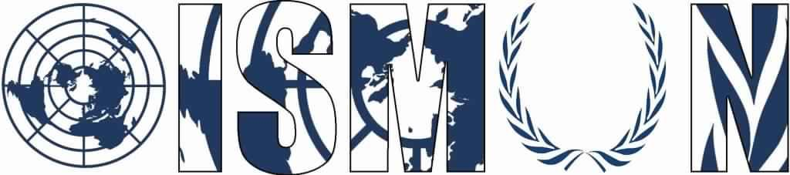

OASIS INTERNATIONAL SCHOOL MODEL UNITED NATIONS

United Nations Office on Drugs and Crime

President: Farida Abu Arab

Vice-president: Aly Imam

Guiding Package

Topic: Preventing drug trafficking and production in Latin America
11th Annual OISMUN Conference

Table of Contents
- Abstract1
- Introduction2
- Definition of key terms 3
- Background information4
- Major countries and organizations involved6
- UN involvement 8
- Possible solutions 9
- Guiding questions9
- Useful links 10
- Bibliography11

- ABSTRACT
Over the past decade, the world has experienced a significant rise in trafficking and production of illicit drugs. According to the united nation’s office on drugs and crime, drug trafficking is a global illicit trade involving the cultivation, manufacture, distribution and sale of substances which are subject to drug prohibition laws. Cocaine and methamphetamine are extending beyond their usual regions and it continues to grow rapidly, despite the success in shutting down popular trade platforms.
Drugs trafficking in Latin America has been growing in the past few years, they have been considered the main producers of cocaine and prohibited drugs. They have been smuggling these drugs throughout the world and creating a bigger and wider chains. Drug lords have been increasing drug trafficking and production until they conquer the drug market. The amounts produced have been multiplying significantly in the year 2000s. The drug trade in Latin America has grown into a multi-billion-dollar industry that generates more revenue than most legal exports and employs tens of thousands of people, and has spread widely through the region, which became a threat to all countries, and is continuously expanding every day.
Governments and global organization have been putting remarkable efforts aiming to decrease the drug trafficking and production of illicit drugs in many ways, and are taking actions in order to make the drug trafficking process harder with point guards, airport checkpoints and inspection units everywhere around the borders.

- INTRODUCTION

The world is facing a potential expansion of drug markets. Crime groups across Latin America are continuing to expand their drug trafficking production activities to finally include synthetic drugs that are becoming increasingly popular in the region. American anti-narcotic officers have been trying to get in collaboration with the authorities of the Latin American countries based on the decision of the American congress in order to investigate drug cartels, share intelligence, and promote collaboration in that case. The US government has provided a budget to aid countries in return for their help to stop the drug trafficking process in their countries. In addition, some governments are stepping ahead and legalizing marijuana, a policy that would potentially take a large part of crime groups’ profits.
Finally, the drug trade is one of the most successful illicit industry in the world, and it represents the main source of income for most of the powerful criminal groups in Latin America. Thus, the drug trafficking and production will be playing a key role in shaping the future of organized crime in the region unless we void the issue.

- DEFINITION OF KEY TERMS
Drugs: A medicine or other substance which has a physiological effect when ingested, normally used under medical supervision.

Illicit drugs: They fall into two categories, the first category contains drugs that are illegal to process, sell, and consume. These include cocaine, methamphetamine, and heroin. The second class includes drugs that are legal to process, sell, and consume when prescribed by a physician, but are then misused, or are used by individuals not under a prescribing doctor’s care, and who may have obtained the drugs illegally.

Smuggling: To import or export goods illegally into or out of a country.

Narcotic: A drug that produces numbness or stupor; often taken for pleasure or to reduce pain; extensive use can lead to addiction.

Drug cartels: A group or band formed to control the production and distribution of narcotic drugs.

Coca: A tropical American plant that is widely grown for its leaves, which are th source of cocaine.

Psychotropic substance: Any chemical agent affecting the mind or mental process.

Methamphetamine: Methamphetamine is a stimulant drug usually used as a white, bitter-tasting powder or a pill. Crystal methamphetamine is a form of the drug that looks like glass fragments or shiny, bluish-white rocks.

Synthetic: A synthetic substance is a substance made chemically with a goal to imitate a natural product.
- BACKGROUND INFORMATION

Drug trafficking in Latin America can be linked back to the early 19th century. The beginning of large scale trafficking in Latin America originated with the production on coca and coca based goods in Peru and the movement of opium and marijuana from Mexico into the United States. The drug trade and rise of drug cartels also formed a large threat to the internal and external security of neighboring Latin American countries especially nations such as Bolivia and Peru.
Globalization has led to a significant increase in drug trafficking. More 420 million shipping containers traverse seas every year, representing 90 percent of the world’s cargo. When it comes to drug trafficking, Mexico and Colombia are ranked first as they are the major drug traffickers in Latin America. They make 18 to 40 billion dollars per year as a total amount of the drug selling process.
Fig1.
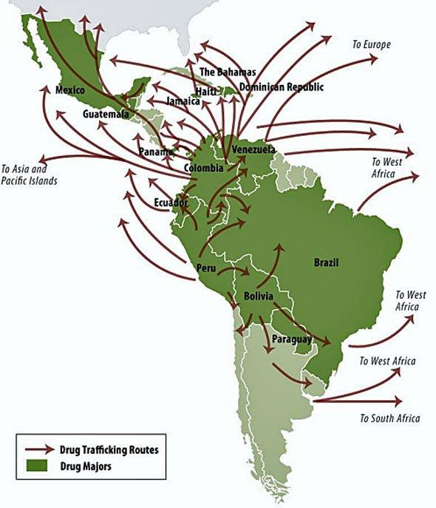
This graph represents the major drug smuggler countries as well as the routes they choose to use while exporting unwholesome, illegal substances.
The United Nations Office on Drugs and Crime’s World Drug Report for 2005 estimates the size of the global illicit drug market at 321.6 billion $, although most jurisdictions prohibit trade, except under license.
The world GDP is of 36 trillion $, which means in 2005 drug trafficking took proximately 1% of the global trade. The consumption of those illegal drugs is widely spread all over the globe.
The law prohibits the illegal drug trafficking and consumption. The penalty imposed mostly depends on the type of drug, the amount of the drug and the age of the dealer, and it also depends on which country you’re in. It leads to severe penalties in many countries and may lead to death penalty in others. The drug consumption and trade lead to direct violence such as murder.
Most of the world’s cocaine comes from Colombia, which represents more than one third of its manufacture from 2015 to 2016, to some 866 tons. The total area under coca bush cultivation worldwide in 2016, was 213,000 ha, which is almost 69 percent of which was in Colombia. Cocaine is mostly reported to be present and transported from central and south America, and specifically from Colombia, and it’s trafficking flows differ depending on the destination (as shown in fig.1).

- MAJOR COUNTRIES AND ORGANISATIONS INVOLVED

- Latin American countries, such as:
Venezuela, Haiti, Puerto Rico: They are proven to smuggle illegally drugs to the United States and Europe and are considered the most involved in the drugs trafficking.
Mexico: One of the main producers of illegal drugs and according to the United States has the most dangerous drug cartels as they are main drug smugglers to the country.
Colombia: Main producer of coca in the world, produced 49000 hectares in 2012 according to the united nations and increased it to become 146000 hectares in 2016.

- United States of America
Main country fighting against drug trafficking and production, as well as one of the most countries affected by the issue.

- United Kingdom
Main importer of drugs and Europe’s most affected countries, mainly by cocaine followed by all other types of drugs.

- International drug conventions:
The three main conventions are:
- Single Convention on Narcotic Drugs of 1961 as amended by the 1972 Protocol establishes an international control system for narcotic drugs.
- Convention on Psychoactive Substances of 1971 establishes an international control system for psychotropic substances.
- United Nations Convention against Illicit Traffic in Narcotic Drugs And Psychotropic substances of 1988, which provides comprehensive measures against drug trafficking.

- UN INVOLVMENT
The United Nations created the United Nations Office on Drugs and Crime, known as the UNODC to focus their studies on the illegal drugs trade and find solutions to prevent and stop the drug trafficking and production.
The office has put three major drug control conventions, the Single Convention on Narcotic Drugs (CND) of 1961 (as amended in 1972), the Convention on Psychotropic Substances of 1971, and the United Nations Convention against Illicit Traffic in Narcotic Drugs and Psychotropic Substances of 1988, that are mutually supportive and complementary.
In October 2016, the UNODC has launched a program or a project under the name of CRIMJUST in order to address organized crime and drug trafficking across regions, and announced that ten countries in Latin America and Africa will participate. And to achieve this objective, the UNODC will assist the countries participating in the program in strengthening the integrity and capacity of their criminal justice systems, with the goal of successfully prosecuting cases of drug trafficking.
UNODC has an important role in assisting each body in performing their treaty-based functions, and in assisting States Parties in the implementation of their obligations under the international drug control treaties. As well as the office helps the abolishment of this issue by supporting member states in addressing drug use and drug addiction as any other health disorder.

- POSSIBLE SOLUTIONS
- Use high technological instruments in the securing the borders and preventing drug trafficking and production.
- Send UN rapporteurs to the borders of the countries with high percentage of drug trafficking to supervise.
- Provide aid to Latin American countries in order to

- GUIDING QUESTIONS
- What is drug trafficking and production? Why is it considered a crime?
- Where in Latin America are drugs predominant?
- What actions should be taken against these crimes?
- What kinds of drugs can be tolerable or legally consumed?
- What are the effects of drug consumption on human beings.
- What is the stance of your country in that matter?
- How does drug trafficking affect your country?
- How does your country make efforts in order to fight drug trafficking (in or outside the country)?

- USEFUL LINKS

The latest world drug reports by the UNODC: https://www.unodc.org/wdr2018/index.html

How Meth, Cocaine, and Heroin Move Around the World:
https://news.vice.com/article/drug-trafficking-meth-cocaine-heroin-global-drug-smuggling

Terminology and information on drugs: https://www.unodc.org/documents/scientific/Terminology_and_Information_on_Drugs-3rd_edition.pdf

United Nations Treaty Collection: https://treaties.un.org/Pages/ViewDetails.aspx?src=TREATY&mtdsg_no=VI-18&chapter=6&clang=_en

Information on the UN drug control conventions:
https://www.tni.org/en/publication/the-un-drug-control-conventions

- BIBLIOGRAPHY

HAMILTON, Kegan, Vice News, “The Golden Age of Drug Trafficking : How Meth, Cocaine, and Heroin Move Around the World”, (April 2016), [Online], Accessible on: https://news.vice.com/article/drug-trafficking-meth-cocaine-heroin-global-drug-smuggling

Congressional Research Service, “Latin America and the Caribbean: Illicit Drug Trafficking and U.S. Counter Drug Programs”, (May 2011), [Online], Accessible on: https://fas.org/sgp/crs/row/R41215.pdf

L.BROWN, Robert, Linked in, “How Drug Trafficking in Latin America has become a U.S. Problem”, (November 2015), [Online], Accessible on: https://www.linkedin.com/pulse/how-drug-trafficking-latin-america-has-become-us-problem-robert-brown

ARMENTA, Amira, JELSMA, Martin, tni, “The UN Drug Control Conventions”, (October 2015), [Online], Accessible on: https://www.tni.org/en/publication/the-un-drug-control-conventions

WOODY, Christopher, Business Insider, “Here’s how drugs are smuggled from South America to the U.S.”, (September 2017), [Online], Accessible on: https://www.businessinsider.com/heres-how-drugs-are-getting-smuggled-from-south-america-to-the-us-2017-9

UNODC, “Drug trafficking”, (2010), [Online], Accessible on: https://www.unodc.org/unodc/en/drug-trafficking/index.html

We are the Drug Policy Alliance, “The International Drug War”, [Online], Accessible on: http://www.drugpolicy.org/issues/international-drug-war

MCDERMOTT, Jeremy, Insight Crime, “Bolivia: The New Hub for Drug Trafficking in South America”, (October 2014), [Online], Accessible on: https://www.insightcrime.org/investigations/bolivia-the-new-hub-for-drug-trafficking-in-south-america/

Find more information on the graph on : https://www.businessinsider.com.au/this-quote-explains-everything-about-the-drug-trade-2015-1
ha: Hectare, a unit of measurement equal to 10 000 square meters.

