OASIS INTERNATIONAL SCHOOL MODEL UNITED NATIONS

General Assembly

President: Nour El Meery
Vice-President: Youssef El Massry

Guiding Package
Topic: Press Censorship and Internet Governance

11th Annual OISMUN conference
Table of contents
- Abstract………………………………………………….…………………….…………2
- Introduction………………………………….…………………………...………………3
- Definition of key terms…………………………………………………………………..4
- Background information………………………………………………………………...7
- Major countries and organizations involved…………………………………..……...9
- UN involvement………………………………………………….…………………….10
- Possible solutions……………………………………..………………………..……..11
- Guiding questions……………………………………………………………..……….11
- Useful links………………………………………………….…………..……………...12
- Bibliography………………………………………………….………….……………..13

- Abstract:
Censorship is the suppression of any type of expression possibly threatening the political or social order, it may be imposed by governmental, local or religious authorities. Nowadays, this term can be implied on the press, as a lot of governments and religious authorities control the press by prohibiting the ideas that might threaten them or is forbidden in this religion, despite that, a lot of journalist defy these rules of censorship and write about forbidden, illegal or taboo topics, in this case some governments try to intimidate them by exiling them or jailing them. Not only does it have to be on forbidden topics but they could also be silenced if they leak confidential information that the government wants to hide or maybe use this platform as a resort to violence. This censorship may also be imposed on the internet, and in this case, it’s called internet governance. Some countries use a technology called intranet to have control over their population’s internet access. The censorship is a major problem as it has the potential to breakdown societies and destroy people’s creativity, as it the idea of freedom of speech and press has almost disappeared in these days.

- Introduction:
In our present day, we live in a world that’s connected. Obtaining access to technology devices that allow us to ingress the internet is more common, the numbers are in the process of augmenting and keep on progressing to this second. All source and kinds of predators as well as online dangers are exposed to consumers. Thus, content is restricted to certain types/ groups of ages. The development of these restrictions and limits has helped the arise of the phenomenon of censorship and internet governance. Through this notion, governments have made advancements in imposing curtailments to their citizens. People are denied the right to specific data and to all, this has become common knowledge. Furthermore, they believe that they could possibly be not only monitored by their own authority regime but also outside ones as well. A human’s rights allow them to express their thoughts aloud freely, however, with our modern-day machinery, people turn to the usage of networked methods like for example, blogging. The United Nations has worked and thrived towards trying to find efficient and effective solutions that might work in order to please everyone. They have suggested multiple methods and actions that will help secure the internet and ensure the people’s wired, digital rights.

- Definition of key terms:
- Censorship: “it’s the suppression of words, images, or ideas that are considered offensive or forbidden in a certain religion”
- Internet governance: “it’s the government control over the internet, by reshaping it and or censoring its content”
- Intranet: “: a local or restricted communications network that is governed by an authority”
- Dark web: “it’s a part of the World Wide Web that can only be accessible using special software, allowing the surfer and website operators to remain anonymous or untraceable”
- Cyberspace: “it’s the online world of computers where they interconnect”
- Cybersecurity: “it’s the defense system of computers against theft, hardware or software damage”
- Cybercrime: “it’s a computer or network-oriented crime”
- Cyber-attack: “it’s an attempt by a hacker to damage or destroy a computer network or system”
- Digital piracy: “practice of illegal copying and commencing digital copyright content”
- Hacktivism: “a person who gains unauthorized access to computer files or networks in order to further social or political ends”
- VPN: “stands for virtual private network is a service that lets you unlock certain blocked websites, social media or internal network so you can access it freely, regardless of the censorship imposed on your area/ region”
- Background information:
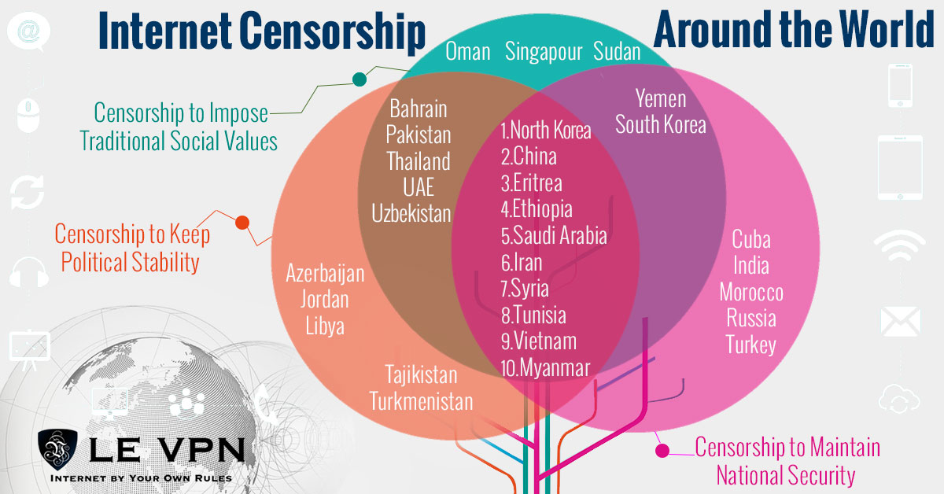
This Venn diagram represents censorship around the world. Those who are within the brown circle are the nations that impose censorship to keep political stability as well as to impose traditional values. Those who are within the extremities of the dark pink intersection are those who impose censorship for all the reasons listed in the graph. 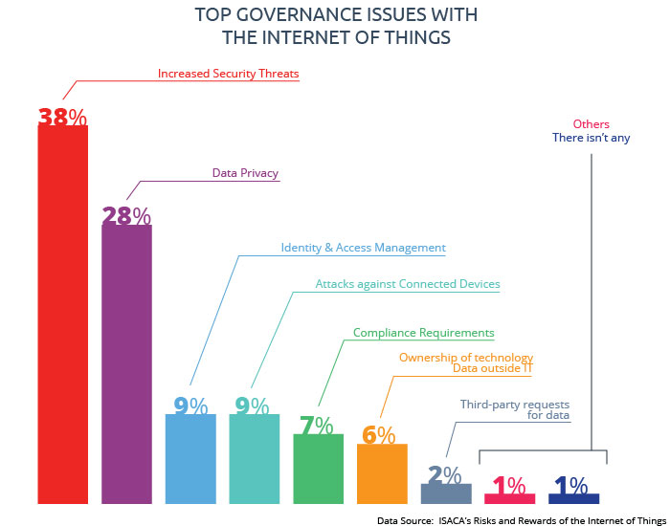
This block graph explains visually the issues of internet governance. It is showing the risks of dangers on the reactions of certain violent users and their actions towards this type of supervision.
The internet has become and is becoming wider every day. It is starting to become a more crucial system to all civilians. There is an increase in jurisdictional conflicts between states and countries over the control of internet governance and supervision. Citizens demand more online expression, digital privacy, trademark protection and copyrighted material.
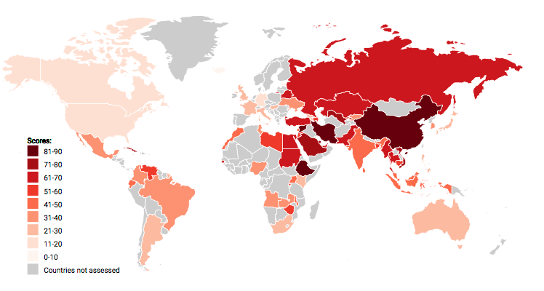
The Freedom on the Nat organization has ranked countries all around the world on its internet freedom where 0 represents the most freedom and 100 is the worst. We can see the areas where the color is darkest (closest to a ranking of 100) are mostly in Europe and Asia and majorly represented by developed and developing countries. If you want to check the exact number for each country then please go to the full report by the Freedom House organization.
Since 2016, people have started to get punished more on more because of their actions on social media, whether I t was standing/ agreeing with someone else or posting your political opinion online. Studies show that 27% of internet users live in countries where people have been arrested for publishing or sharing content on Facebook.

- Major countries and organizations involved:
- Major countries involved:
- The State of Eritrea: the government of the state of Eritrea created a climate that obligated reporters to live in constant fear of arrest. The threat of imprisonment has led many journalists to choose exile rather than risk arrest. Eritrea dismissed plans in 2011 to provide mobile internet for its citizens, limiting the possibility of access to independent information.
- The Democratic People’s Republic of Korea: nearly all the content of North Korea’s 12 main newspapers, 20 periodicals, and broadcasters comes from the official Korean Central News Agency, which focuses on the political leadership’s statements and activities. There are internet restrictions to the political elite, but a lot of schools and state institutions have access to a controlled intranet called “Kwang Myong” with a search engine called “our country” that helps the user navigate around an estimated 5500 websites.
- Switzerland: the government did not apply any restrictions on access to the internet nor there are credible reports that the government monitored e-mail or internet chat rooms without appropriate legal authority. The constitution ensures the freedom of discrimination, spreading racist ideology.
- The Islamic Republic of Iran: the government uses arbitrary detention as a mean of silencing dissent and forcing journalists into exile as well as it became the world's leading jailer of journalists in 2009 and as ranked among the world's worst jailers of the press every year since. The Iranian authorities maintain one of the toughest Internet censorship regimes in the world, blocking millions of websites, including news and social networking sites.

- Major organizations involved:
- The International Information System Security Certification Consortium: is a non-profit organization which specializes in training and certifications for cybersecurity professionals. It’s considered one of the largest IT security organization in the world. They offer the most known certification worldwide. In June 1988, a conference was hosted by the National Institutes of Standards and Technology and the Federal Information Systems Security Educators Association and the participants agreed to form a consortium that would attempt to bring together the competing agendas of the various organizations.
- The Global Cyber Security Center (GCSEC): is a non-profit organization created to develop cyber security around the world. The Center is based in Rome with a strong collaboration with Italian and International government institutions, private institutions and research institutions. Their mission is to develop knowledge and awareness on Cyber Security. It was founded in 2008, and since then it has developed technologies of management and intelligence that helps dealing with large volumes of information and cyber security.

- UN involvement:
The United Nations has interfered and taken action press censorship and internet governance several times. They have adopted several General Assembly conferences and meetings in the goal of finding a solution to the issue at hand.
Firstly, commencing with the resolution of their gathering on the 29th of June 2012. In this resolution, they have treated the problem by specifying and emphasizing on the creation of a declaration where all your civil, political, economic, social and cultural rights offline and online should be the same. The barrier should be broken and should not even be tempered with. The articles withhold the general idea of how a person should be able to express their opinion through media with different countries’ facilities.
Please find the link of the full resolution for further information on the resolution
Secondly, the UN condemns internet access disruption as a human rights violation and they do not stand with internet governance, press censorship or any type of online restrictions and blocking systems. The resolutions submitted by the United Nations are not legally binding, however, it puts pressure on authorities. So, the UN has decided to condemn any type of internet shutdown as the number of countries trying to control their citizens while using this method has increased majorly.
If you wish to find a full resolution to enhance your knowledge upon it
Thirdly, the United Nations chief at the meeting on the 13th of July 2018 in Geneva, Switzerland has focused on clarifying the fact that internet governance is a must in a country’s society in order to block any cybercrimes. He claims that for a sustainable world, internet governance is key to protect society from the dangers that come with this type of innovation. Polarization is a risk to all citizens so this is the only way they could secure the lives of their people.
In order to reach the full review of this meeting, please consult.
- Possible solutions:
- Making VPNs and Proxys legal.
- Create a law that bans any type of governing in the basis of protest on media.
- Creating a journalist and speaker protection program where they will be filled with representatives that will defend journalists.
- Create laws that state that people are free to right whatever comes to their mind and social media. Breaking the governments power to arrest or sanction those who speak their mind on media communication methods.

- Guiding questions:
- Why do governments apply restrictions on the internet? What are they hiding and why?
- What have organizations done until now to solve this issue? How have those efforts improved the situation?
- Are there national laws in your country concerning this topic?
- How does this issue affect your country's political status?
- Are these restrictions going against human rights?
- How do VPNs fit into all of this?
- Should there be censors based on your job, age or title?
- How can equality play it/s role in such a topic? Equality of age groups, national equality and international equality.

- Useful links:
- INTERNET GOVERNANCE FORUM, available on: https://www.intgovforum.org/multilingual/, consulted on the 27/6/2018.
- UN NEWS, available on https://news.un.org/en/story/2017/12/639792-un-chief-highlights-need-internet-governance-support-innovation-prevent, consulted on the 27/6/2018.
- UNITED NATIONS HUMAN RIGHTS COUNCIL RESOLUTION, available on https://www.article19.org/data/files/Internet_Statement_Adopted.pdf, consulted on the 27/6/2018.
- INDEPENDENT, available on: https://www.independent.co.uk/news/world/the-map-that-shows-the-countries-with-the-least-press-freedom-in-the-world-a6996676.html, consulted on the 24/6/2018.
- SCRIPTA NOVA, available on: http://www.ub.edu/geocrit/sn/sn-270/sn-270-151b.htm, consulted on the 24/6/2018.

- Bibliography:
- Tech church, available on https://techcrunch.com/2016/07/01/un-agrees-to-adopt-expanded-resolution-on-online-speech-rights/, consulted on the 27/6/2018.
- The verge, available on https://www.theverge.com/2016/7/4/12092740/un-resolution-condemns-disrupting-internet-access, consulted on the 27/6/2018.
- Independent, available on https://www.independent.co.uk/life-style/gadgets-and-tech/un-declares-online-freedom-to-be-a-human-right-that-must-be-protected-a7120186.html, consulted on the 27/6/2018.
- OSCE (organization for security and co-operation in Europe), available on https://www.osce.org/fom/250656, consulted on the 27/6/2018.
- Marketplace, available on: https://www.marketplace.org/2016/05/27/world/social-media-censorship-around-world, consulted on the 24/6/2018.
- Council on foreign relation, available on: https://www.cfr.org/backgrounder/what-internet-governance, consulted on the 24/6/2018.
- Internet society, available on: https://www.internetsociety.org/issues/internet-governance/, consulted on the 24/6/2018.

Freedom House 2017, available on https://freedomhouse.org/report/freedom-press/freedom-press-2017 consulted on the 27/6/2018.
General Assembly resolution 2012, available on http://ap.ohchr.org/documents/E/HRC/d_res_dec/A_HRC_20_L13.doc consulted on the 27/6/2018.
United Nations Article 19, available on https://www.article19.org/explore, consulted on the 27/6/2018.
United Nations News, available on https://news.un.org/en/story/2017/12/639792-un-chief-highlights-need-internet-governance-support-innovation-prevent, consulted on the 27/6/2018.

